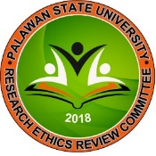** PALAWAN STATE UNIVERSITY**

**RESEARCH ETHICS REVIEW COMMITTEE**

Tiniguiban Heights, Puerto Princesa City, 5300 Palawan

*Email*: [psurecpal@gmail.com /](mailto:psurecpal@gmail.com) [psurercsubmissions@psu.palawan.edu.ph](mailto:psurercsubmissions@psu.palawan.edu.ph)

**FORM 2.I D ASSIGNMENT OF PRIMARY REVIEWERS**

|  |  |
| --- | --- |
| **PSURERC Protocol Code:** |  |
|  | |
| **Sponsor/Funding Agency** |  |
|  | |
| **Principal Investigator/Researcher:** |  |
|  | |
| **Primary Reviewers:** | 1. |
| 2. |
|  | |
| **Independent Consultant:** |  |
|  | |
| **Assigned by:** |  |
|  | |
| **Date:** |  |
|  | |
| **Type of Review:** | Expedited Fullboard |
|  | |
| **Date Due:** |  |

*PSURERC Form 2.1D*

*Assignment of Primary Reviewers*